Prologue

Effective macroprudential policy implementation implies forward-looking management of risks to the real economy arising from financial imbalances. Given the cyclical nature of the accumulation and materialization of risks in the financial system,
- Macroprudential policy (hereinafter referred to as MCP) builds capital and liquidity reserves through the use of restrictive/restraining instruments during the upswing of the cycle,
- which can be used during a crisis to absorb losses and ensure the smooth functioning of financial intermediation.
The tools mentioned in the first point (tightening of capital requirements, tightening of requirements for borrowers, etc.) have a negative impact on economic activity in the short term, as they are essentially aimed at reducing lending. The benefits of using these tools may manifest themselves in the medium or long term, when lending can be stimulated by weakening the already accumulated buffers, thereby reducing the risks of disruption of the continuity of lending.
In other words, in essence, conducting a CSP involves establishing a certain balance (trade-off) between the short-term costs of the policy (possible reduction in GDP) and the benefits in the long term (reduction of risks). For effective CSP management, it is necessary to have a reliable measurement of both costs and benefits, which can be done using the Growth-at-Risk (GaR) model.
The GaR model can answer the following key questions:
- How have the risks to economic growth changed (in the recent period, or at any point in the past)?
  - Which part of these risks is caused by the financial system, and which part by other factors (including macroeconomic ones)?
- How will these risks change in the short-/medium-/long-term?
  - if the MPC remains unchanged
  - if the MPC is tightened/weakened
- What is the most effective step in the MCP from the perspective of the policy implementer?

What is GaR?

The Growth-at-Risk system was proposed by the IMF and has become widely popular since 2019.
The system is designed to model the distribution of GDP. From a technical point of view, it is based on quantile regressions, which allow modeling not only the central value of the variable, as is the case with conventional regression, but the entire distribution, including the median, right and left tails.
The workflow for applying GaR is as follows:
- choose the dependent variable (usually the annual growth rate of real GDP is chosen)
- select dependent variables (variables characterizing the financial sector + macroeconomic variables + variable approximating the MPC instrument)
- estimate quantile regressions (one equation for each quantile)
- recover the distribution of the dependent variable using estimated equations
The median of the resulting distributions is usually interpreted as the central prediction, and the left tail as an approximation of the risk.
From a financial stability perspective, the GaR system is important in terms of depicting the nonlinear nature of the interaction between dependent and independent variables. For example, the MPC variable may have different sign/size coefficients in the median and left tail equations of GDP, which may indicate that MPC tightening affects the central GDP forecast and riskiness differently (this effect may also be differentiated in different horizon models; usually GaR is estimated for 1, 2, and 3 year horizons, which may provide additional interpretations of the short-term and long-term effects of MPC).
Typical GaR system and results . Below is an exemplary and highly simplified model of GaR and its interpretation.

Forecast of GDP distribution 1 year from now based on today's developments
$${GDP}_{t+4| 10th quantile}=0.25*{Inflation}_{t}+{0.05*Credit}_{t}+0.08*{MacroPru}_{t}$$
$${GDP}_{t+4| median}={0.28*Inflation}_{t}+0.01*{Credit}_{t}-{0.05*MacroPru}_{t}$$

Forecast of GDP distribution 2 years from now based on today's developments
$${GDP}_{t+8| 10th quantile}=0.18*{Inflation}_{t}+{0.08*Credit}_{t}+0.12*{MacroPru}_{t}$$
$${GDP}_{t+8| median}={0.28*Inflation}_{t}+0.01*{Credit}_{t}+{0.01*MacroPru}_{t}$$

In the system described above, only the equations for the left tail and median of GDP are given, but in the real model, equations for n quantiles can be estimated. The key here are the estimated coefficients of the MPC variable. According to the estimates of the estimated equations for a one-year horizon (the first two equations), tightening the MPC by one point will worsen the median of GDP by a conditional 5%, but the riskiness will improve by 8%. In the long run, the benefits of using the MPC become more tangible: riskiness is reduced by 12%, while the median of GDP has a small improvement of 1%.
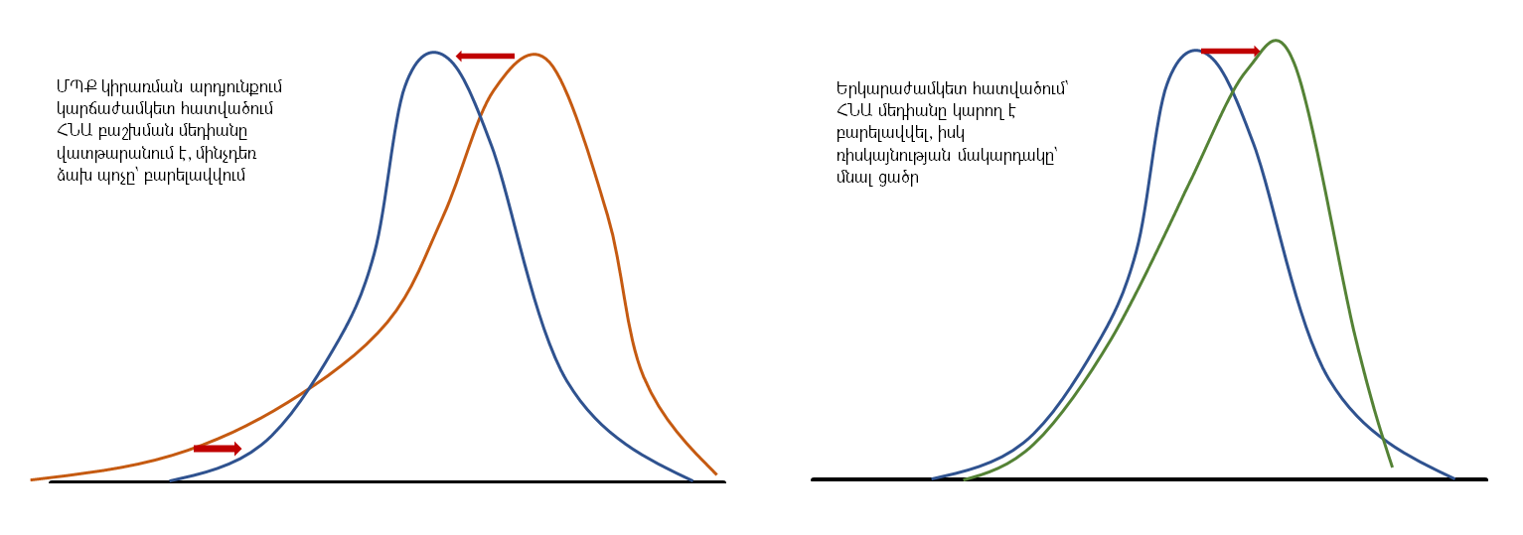

The estimated model for the financial system of Armenia

Local data-based model . The estimated system for the RA financial system includes 3 sub-models, in which the real GDP growth rate for 1, 2 and 3 years acts as the dependent variable. The independent variables are as follows:
- Financial cycle index , which indicates the degree of risks accumulating in the system
- Financial Conditions Index, which is the actual degree of stress. The semantic difference from the previous indicator is that shocks recorded in the system are not always the result of risks accumulated within the system (they can be caused by external factors, etc.). This index includes the following main variables:
  - VIX index
  - Interest rates for different maturities of the RA yield curve
  - bank profitability indicators, etc.
The aggregation of indicators was done using XXXxxxxx (Koop and Korobilis 2007)
- General Index of Macroeconomic Conditions . The purpose of constructing this index is to explain exclusively those changes in the distribution of GDP that are not caused by the financial system. The index does not aim to explain macroeconomic dynamics. It includes the following main variables:
  - inflation
  - exchange rate
  - current account
  - unemployment, etc.
- MPC Index . This indicator was constructed based on the policy steps implemented by the Central Bank in previous years and, in addition to the MPC instruments themselves, also includes changes in risk weights, changes in mandatory reserves, etc. The indicator was constructed by calculating a sliding sum over a 3-year window and shows the cumulative impact of the MPC with the results of the previous 3 years, respectively.
It should be noted that the inclusion of this indicator in the model was done in a special way so that when calculating the MPC effect, the current position of the financial cycle, excess capital reserves, and the degree of stress in the system are taken into account. That is, the estimated coefficient of the model is transformed using a special function so that it includes the current values of the above-mentioned factors, for example, as the excess capital reserves decrease, the MPC effect increases. In addition, the specified function also takes into account the size of the MPC step (through the transformation of the sigmoid function - the purpose of this step is as follows: small MPC steps bring a small result, the effect increases nonlinearly as the step increases, and in the case of very large steps, it decreases with diminishing returns).
- Autoregressive element. This is included to characterize effects not explained by the specified factors.

Panel estimation . In addition to the model estimated with local data, we also estimated the model described above for 42 countries. The necessity of this step was mainly due to the fact that the history of the MPC in the Republic of Armenia is extremely limited, and the magnitudes of the MPC coefficient estimated in the model estimated with only local data may not be stable. In this sense, the results of the panel estimation serve as a kind of robustness check.

Optimal policy choice

The model described above allows us to estimate the potential impact of a step in the MPC of any magnitude on the distribution of GDP. However, from the perspective of the policy-making body, the important question is:
- In the current situation (position of the financial cycle, degree of stress in the system, etc.), what direction should macroprudential policy steps be taken, and
- How big exactly should that step be?
To answer the above questions, we used the approach proposed in the international literature (Suarez 2020), which proposes defining a utility function for policy decisions. It has the following form:
$$U=y_{median}+\frac{1}{2}*w*{(y_{median}-y_{tail})}^{2}$$
where
U – is the utility of the policy step
y _{median} – is the median of the GDP distribution
y _{tail} – is the left tail of the GDP distribution
w – is the risk appetite of the policy-making body.
The formula essentially has 2 main components: return and risk (using the example of an investment portfolio), where:
- income is the median of the GDP distribution
- Risk is the distance-to-tail of the GDP distribution.
It is worth noting that the final utility of the MPC step includes the sum of the present value of the utilities across all horizons (recall that the GaR model included models estimated for years 1, 2, and 3).
The formula assigns a key role to the w component, which is essentially the policymaker's "fear" of future stress. For example, when the accumulation of risks in the system is high and the "fear" of a future crisis is high, the value of w will be high, thus giving a high weight to the risk component, and therefore to tightening policy (reducing the gap at the expense of reducing the median). Conversely, when the risks of a crisis have already materialized and there are no signs of risk accumulation, w will take on low values, giving a low weight to the risk component and a high weight to maximizing the median of the GDP distribution.
And how to calibrate w? In general, this indicator is qualitative in nature and depends on the discretion of the decision maker. However, within the framework of the GaR model evaluation, an attempt was also made to approximate a benchmark value for this indicator, which was 0.11-0.13. This was done as follows:
- We have assumed that all decisions made previously were optimal, that is, with the best utility.
- Through an optimization problem, we tried to find the average value of w at which the actual decisions would be as close as possible to the decisions suggested by the utility function proposed by Suarez.
Here is the graph of the optimal w.

Results

Model estimation results . Below are the estimated coefficients of the model and their interpretations.
Cite the coefficient table here
Usability from the perspective of MCP decision-making . The results of the model evaluation can be used from the MCP perspective in the following directions:
- For assessing the macroprudential policy stance
Cite the stance graph here
The graph shows the distance-to-tail indicator for previous periods. The graph should be interpreted as follows: an increase in this indicator means that the risks in the system have increased relative to the existing risk-absorbing capacity, and it is necessary to “think” about tightening and vice versa. It has no binding meaning, but only gives an idea of the risks and risk-absorbing capacity, and therefore the possible direction of policy.
Below are graphs depicting the decomposition of the components explaining the change in the position of the MPC:
  - Cite here the decomposition graph of stance
  - Here is the FCyI decomposition graph.
  - Cite here the FCI decomposition graph
  - Cite here the MacroIndex decomposition graph
- Graph depicting GDP distribution
  - current period
  - 1 year later, without MPC
  - 1 year later, with optimal MPC step
Here is a graph of 3 distributions.

- A more detailed graph showing the short-term costs and long-term benefits of an optimal MPC step ( tightening+loosening)
Here is a graph of the effect of tightening+loosening

